

Data Subject Consent Withdrawal Form

Document Classification: | Template – Public  Completed - Confidential
Document Ref. | CC/ITDPO/009
Dated: | 08 May 2023
Document Author: | Stefan Ancilleri
Document Owner: | Stefan Ancilleri

Revision History

Date | Revision Author | Summary of Changes
08/05/2023 | Stefan Ancilleri | Document creation

Distribution

Name | Title
Public

Approval

Name | Position | Signature | Date
Stefan Ancilleri | CIO | 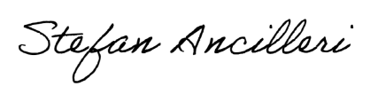 | 08/05/2023

DATA SUBJECT CONSENT WITHDRAWAL FORM

I, _______________________________________________ (data subject name and surname), withdraw my consent to process my personal data from Centrecom.

Centrecom no longer has my consent, which was previously granted, to process my personal data, being:
- Full name and surname
- Contact details
- Photo images
- Video recording
- Access control details
for the purpose of marketing of Centrecom services during its marketing activities, which may include broadcasting, posts on social media and displaying or distribution of photo images by use of paper or electronic means, including but not limited to leaflets, booklets, websites and inter alia.

Data Subject’s details:

Name and surname: ___________________________________________

ID Card Number: ___________________________________________

Signature: ___________________________________________

Date: ___________________________________________

For official use only. Request actioned by Centrecom DPO / GDPR Owner:

Name and surname: _________________________
ID Card No: _________________________
Signature: _________________________
Date: _________________________

